Project Performance Test

Date | 1 July 2026
Team ID
Project Name | Plugging into the Future: An Exploration of Electricity Consumption Patterns
Maximum Marks

Model Performance Testing:
Project team shall fill the following information in model performance testing template.
S.No. | Parameter | Screenshot / Values
 | Data Rendered | File Name: – Consumption_cleaned.xlsx  File Type:- Excel (.xlsx)  No of Rows/Records:- 16587 Rows  No of Columns:- 8  File Size:- 613 KB
 | Data Preprocessing | 1. State Name Standardization  - Standardized abbreviated and inconsistent state names into their official names to maintain uniformity across the dataset.  - Examples:  - MP → Madhya Pradesh  - Pondy → Puducherry  - Jammu&Kashmir → Jammu & Kashmir  2. Latitude and Longitude Formatting  - Formatted all latitude and longitude values to four decimal places to ensure consistent geographic precision and improve readability while maintaining sufficient accuracy for state-level analysis.  3. Usage Value Formatting  - Formatted the Usage column to two decimal places to maintain numerical consistency and improve the readability of electricity consumption values throughout the dataset.  4. Conversion of Dataset into an Excel Table  - Converted the raw dataset into an Excel Table using Excel's table feature.  - This enhanced data organization and enabled efficient sorting, filtering, structured referencing, and easier data management during analysis.  5. Duplicate Record Verification  - Checked the dataset for duplicate records and removed redundant entries wherever necessary to improve data quality and eliminate repetitive records.  6. Missing Value Verification  - Examined the dataset for missing or null values and confirmed that all essential fields contained valid and complete information.  7. Date Format Validation  - Verified that all date values followed a consistent format throughout the dataset, ensuring accurate chronological analysis and visualization.  8. Data Type Validation  - Confirmed that all numerical attributes, including Usage, Latitude, and Longitude, were stored in numeric format, while the Date field was stored in the appropriate date format.  9. Data Consistency Check  - Reviewed the dataset to ensure consistency in state names, regional classifications, and geographical information across all records.  10. Final Data Validation  - Performed a final quality check to verify that the dataset was clean, accurate, well-structured, and ready for visualization and analysis in Tableau.
3. | Utilization of Filters | 1.Pie Chart – Top 5 States Filter by Electricity Usage  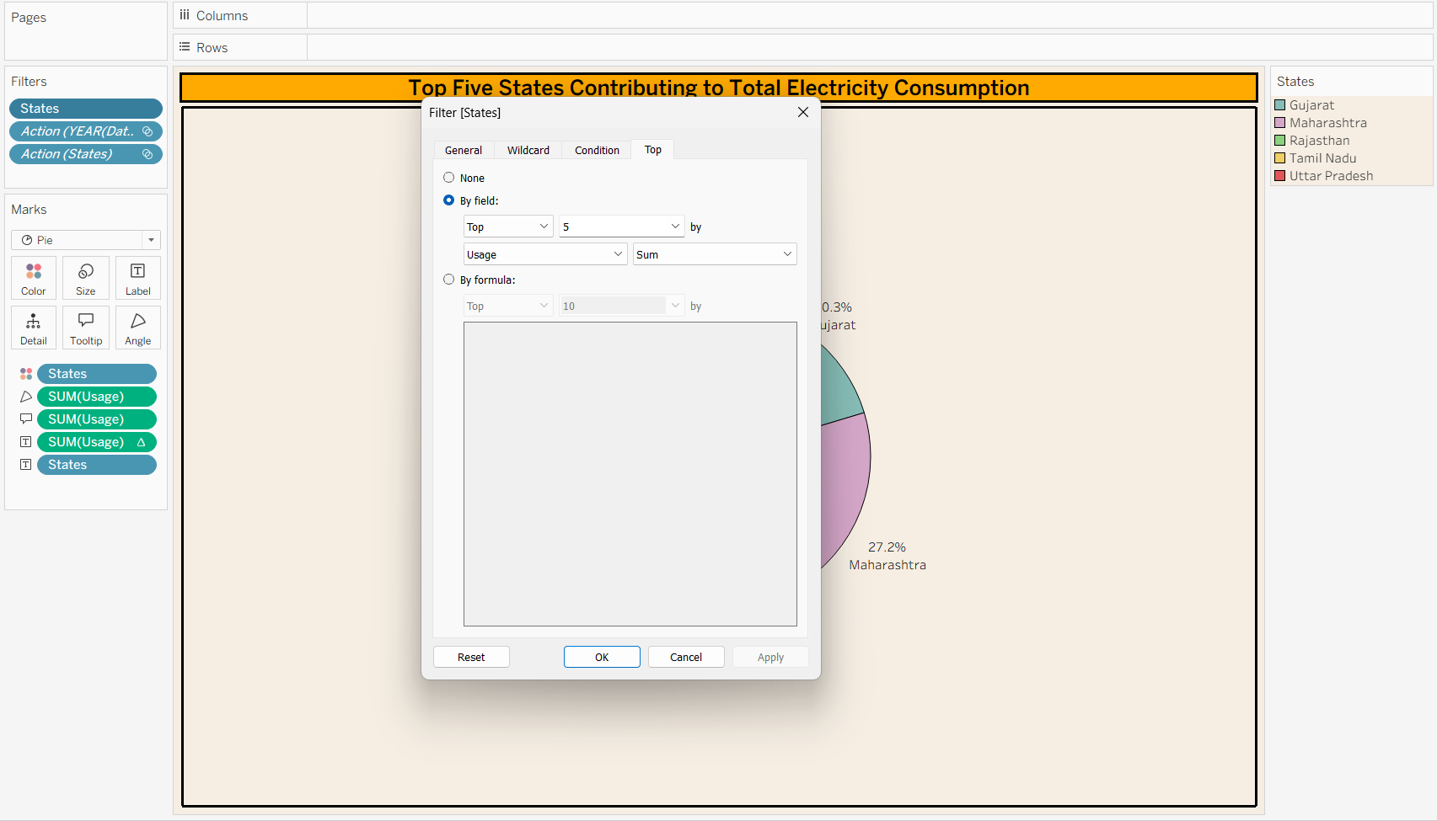  2.Tree Map – Months Filter to track Lockdown Period  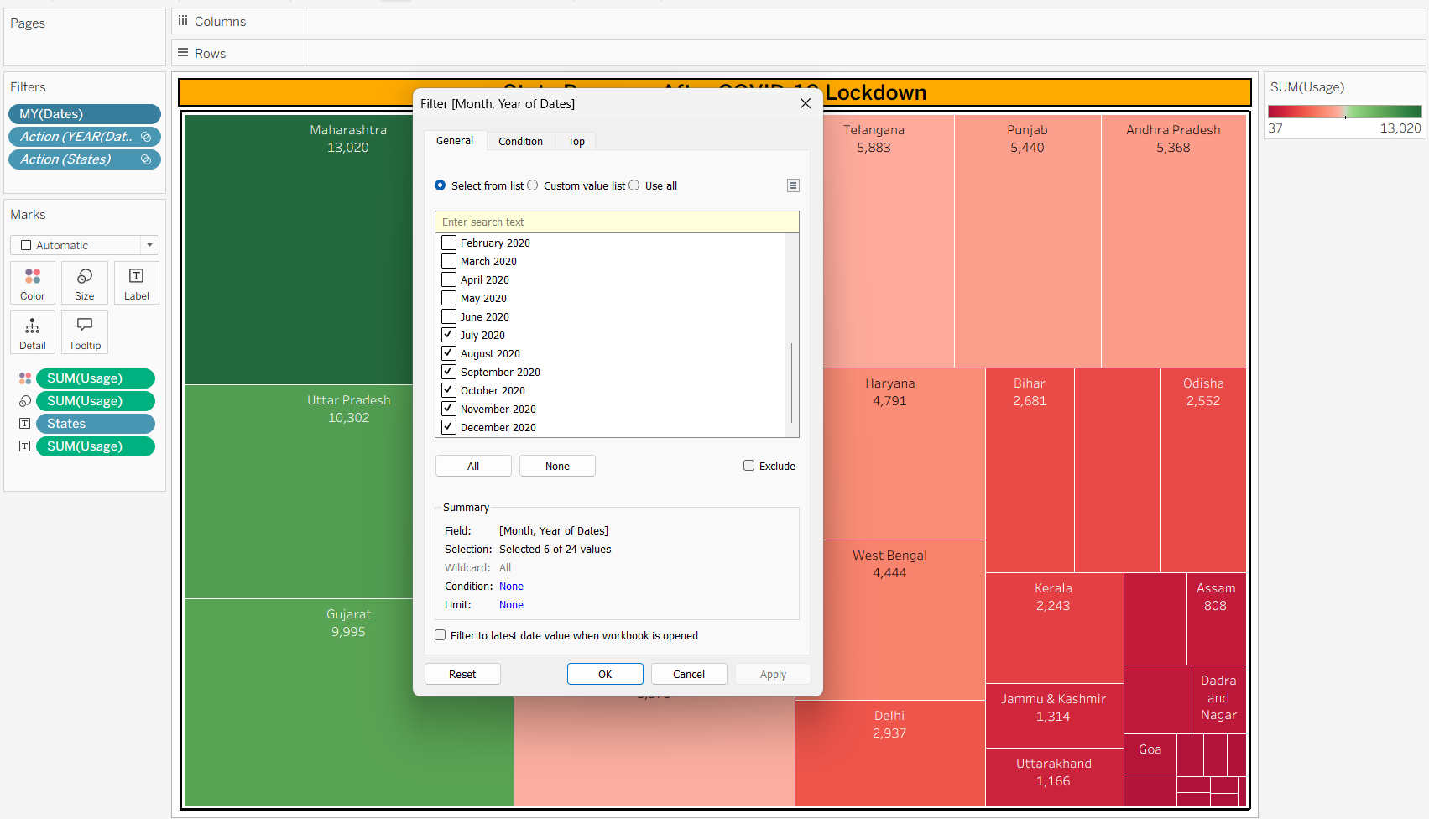
4. | Calculation fields Used | 1.Season – To show the Seasonal Effect on Electricity Consumption  2.No of States - To count the Distinct no of states
5. | Dashboard design | No of Visualizations / Graphs – 10  1.Line Chart  2. Dual Line Chart  3.Horizontal Bar Chart  4.Vertical Bar Chart  5.Pie Chart  6.Symbol Map  7.Heat Map  8.Tree Map  9.KPI-Number of States  10.KPI-Average Electricity Consumption
6 | Story Design | No of Visualizations / Graphs -10

